HISTOGRAM OF IMAGE :

clc;

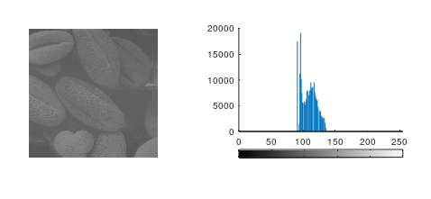close all;

clear all;

pkg load image

I=imread('C:\Users\admin\Desktop\tissues.tif');

[r,c]=size(I);

figure;

subplot(2,2,1)

imshow(I);

subplot(2,2,2)

imhist(I);

Task 1 :   
  
%task 1: contrast stretching

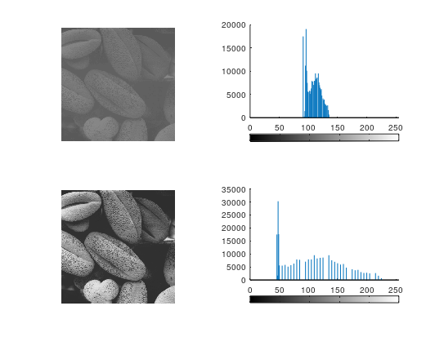L=256;

r1=0;s1=0;r2=100;s2=50;r3=130;s3=200;r4=L-1;

slope1=(s2-s1)/(r2-r1);

slope2=(s3-s2)/(r3-r2);

slope3=(s4-s3)/(r4-r3);

for i=1:r

for j=1:c

if I(i,j)<=r2

g1(i,j)=slope1\*(I(i,j)-r1)+s1;

elseif r2<I(i,j)<=r3

g1(i,j)=slope2\*(I(i,j)-r2)+s2;

else

g1(i,j)=slope3\*(I(i,j)-r3)+s3;

endif

endfor

endfor

subplot(2,2,3)

imshow(g1)

subplot(2,2,4)

imhist(g1)

TASK 2 :-

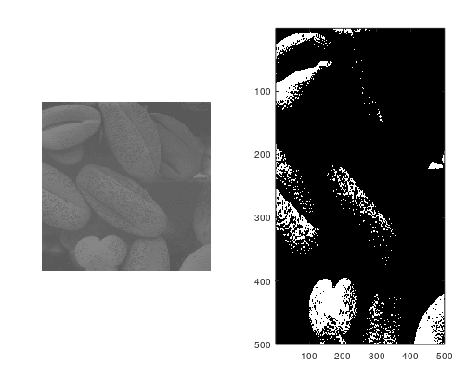I=imread('C:\Users\admin\Desktop\tissues.tif')

[row,col]=size(I);

figure;

subplot(1,2,1)

imshow(I);

Id=double(I);

c=5;

for i=1:row

for j=1:col

g2(i,j)=c\*log10(Id(i,j)+1);

end

end

g3=uint8(g2);

subplot(1,2,2)

imagesc(g3):colormap(gray);

TASK 3 :-

clc;

clear all;

close all;

I=imread('C:\Users\admin\Downloads\Gauss.jpg')

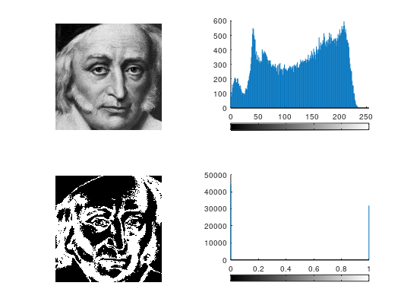[row,col]=size(I);

figure;

subplot(2,2,1)

imshow(I);

subplot(2,2,2)

imhist(I);

for i=1:row

for j=1:col

if I(i,j)<=70

newI(i,j)=0;

elseif(I(i,j)>70)&&(I(i,j)<=170)

newI(i,j)=100;

elseif I(i,j)>170

newI(i,j)=0;

endif

endfor

endfor

subplot(2,2,3)

imshow(newI)

subplot(2,2,4)

imhist(newI)